Survey Report:
The Mental Health Effects of Social Media Addiction

Prepared by: Bhavana Bhati
Date: [06-10-2025]
Target Group: Students & Young Adults (Ages 15–35)
Sample Size: [30 respondents]
Survey Method: Google Form

1. Introduction
This survey was conducted to study how excessive use of social media affects individuals’ mental health, including anxiety, stress, sleep patterns, and self-esteem. Social media has become an inseparable part of daily life, but constant exposure can lead to emotional strain and dependency. The goal of this research is to understand both the positive and negative impacts of social media addiction.

2. Objectives of the Survey
- To analyze the average time spent on social media.
- To identify the most used social media platforms.
- To study the psychological effects such as anxiety, comparison, and sleep disturbances.
- To understand whether social media provides any positive emotional benefits.
- To collect suggestions for reducing social media addiction.

3. Data Analysis
A. Gender Distribution:
- Female:56.7%
- Male: 43.3%
- Other / Prefer not to say: 0%
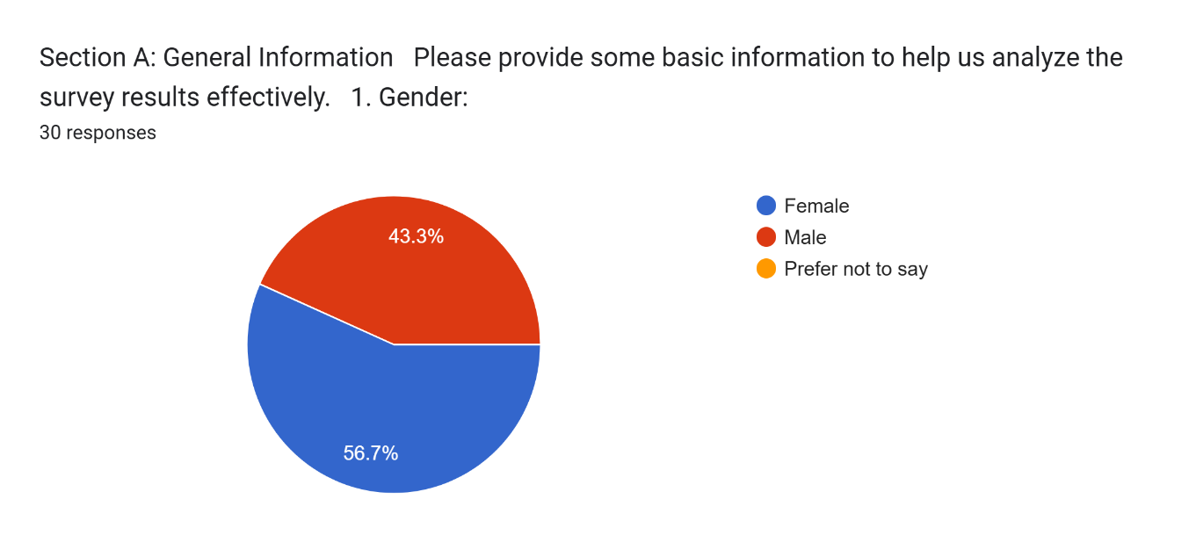

B. Occupation:
- Students: 70%
- Working Professionals: 16.7%
- Self-employed: 13.3%
- Unemployed: 0%
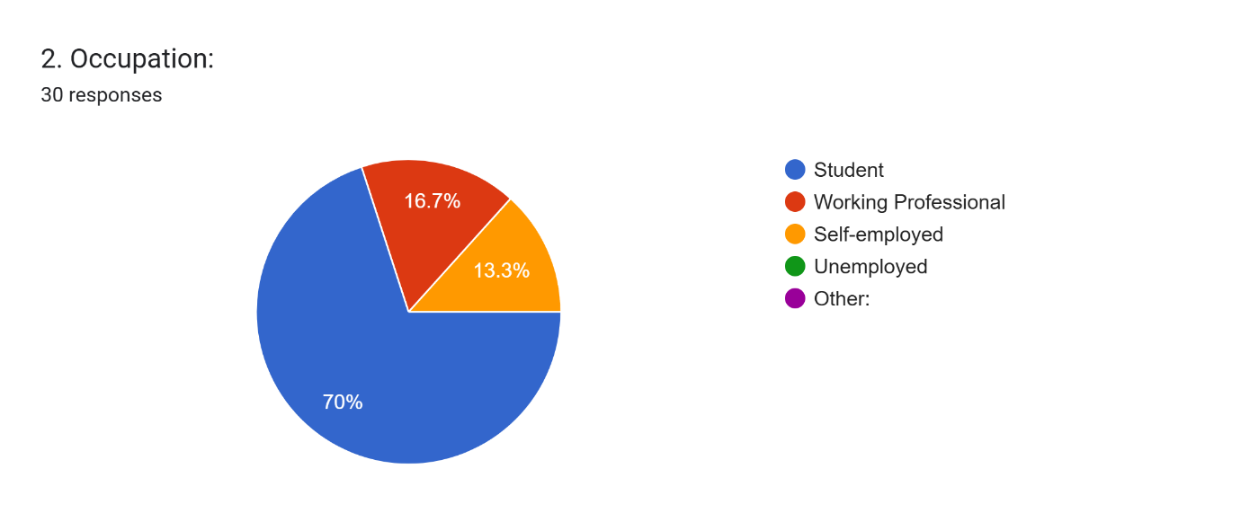
- Other:0%

C. Age Group:
- Below 18: 3.3%
- 18–25: 80%
- 26–35: 13.3%
- 36–50: 3.3%
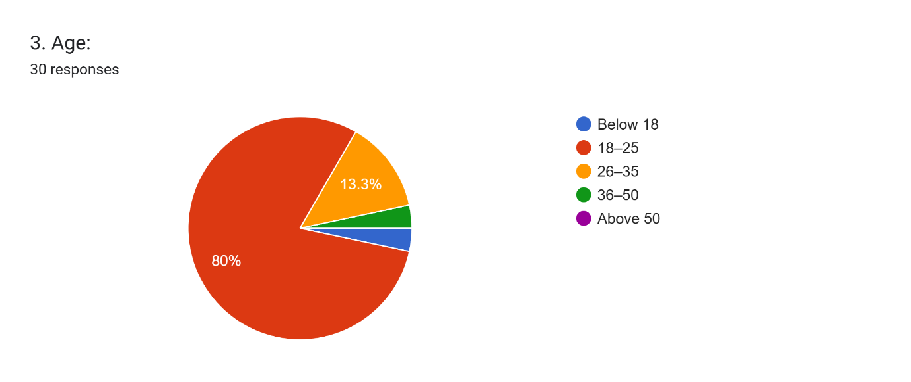
- Above 50: 0%

4. Social Media Usage Patterns
- Less than 1 hour daily: 16.7%
- 1–3 hours: 70%
- 4–5 hours: 10%
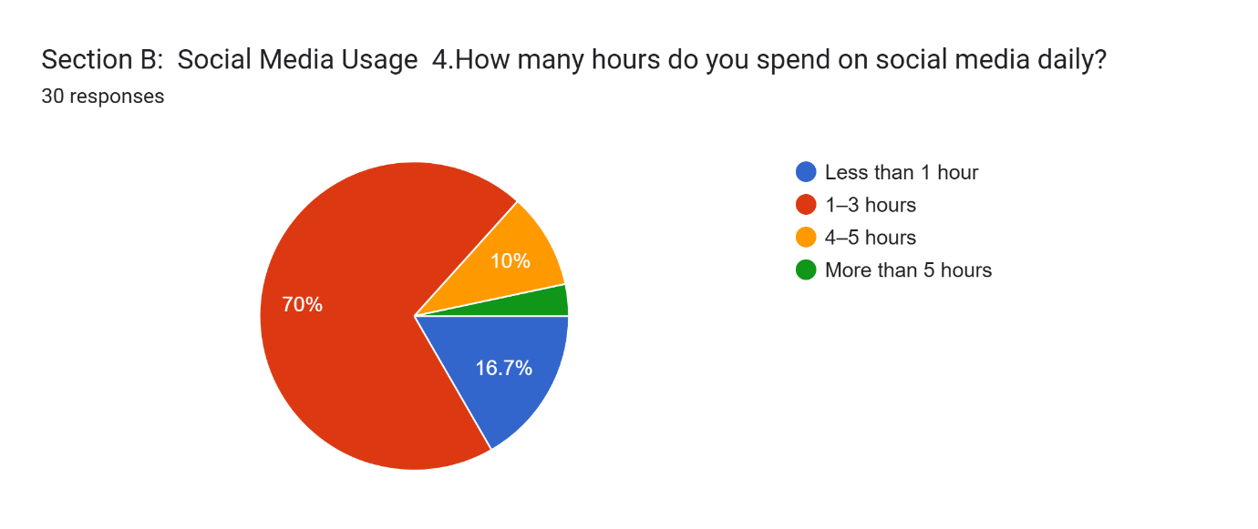
- More than 5 hours: 3.3%

A. Most Used Platforms:
- Facebook: 13.3%
- Instagram: 86.7%
- Twitter/X: 3.3
- TikTok / Shorts / Reels: 3.3%
- WhatsApp / Messaging apps: 63.3%
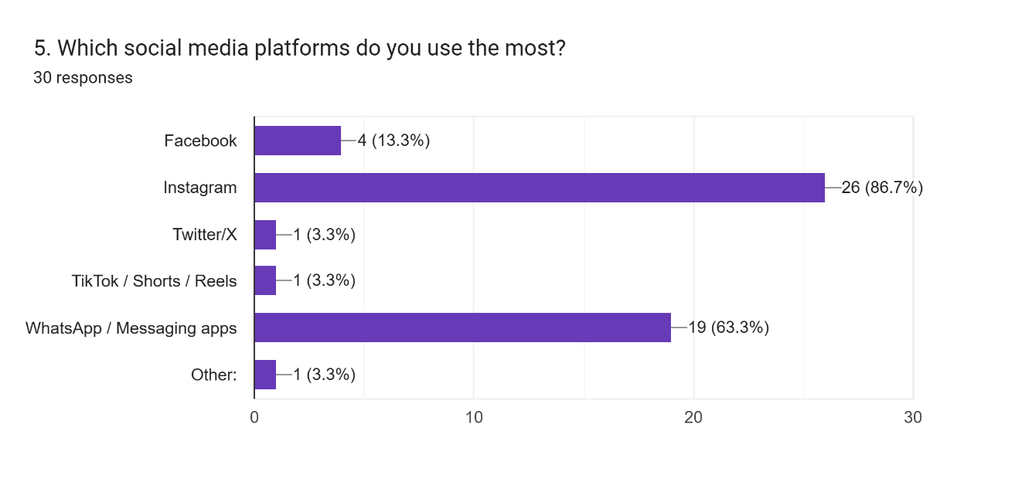
- Other:3.3%

5. Mental Health Effects Observed
- Anxiety or stress due to online pressure: 10%
- Sleep disturbance: 50%
- Low self-esteem due to comparison: 6.7%
- Distraction and reduced productivity: 23.3%
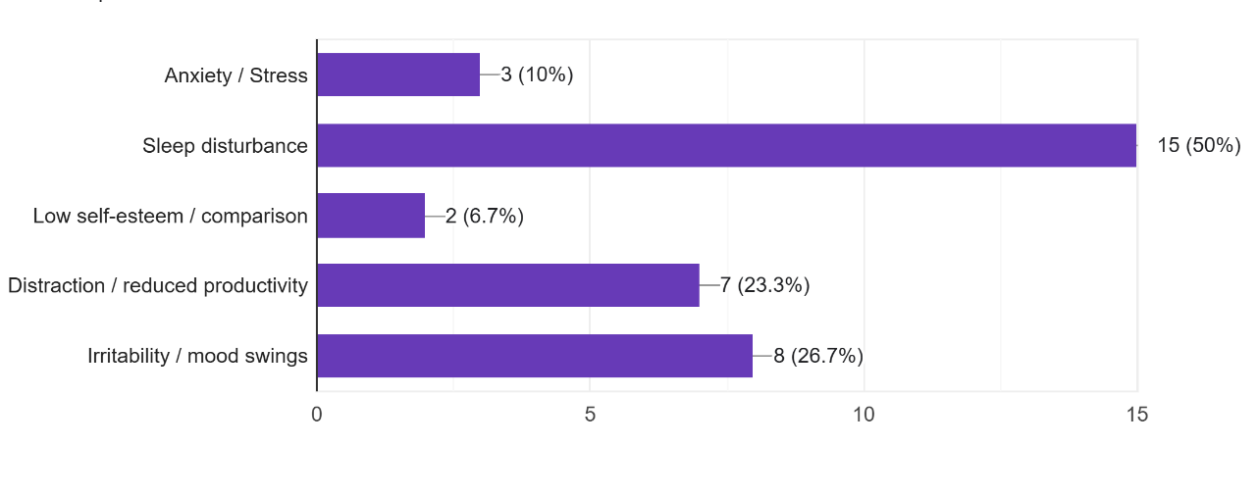
- Mood swings or irritability: 26.7%

6. Positive Aspects Identified
- Yes ,many positive impacts: 20%
- Some positive impacts: 60%
- No positive impact: 20%
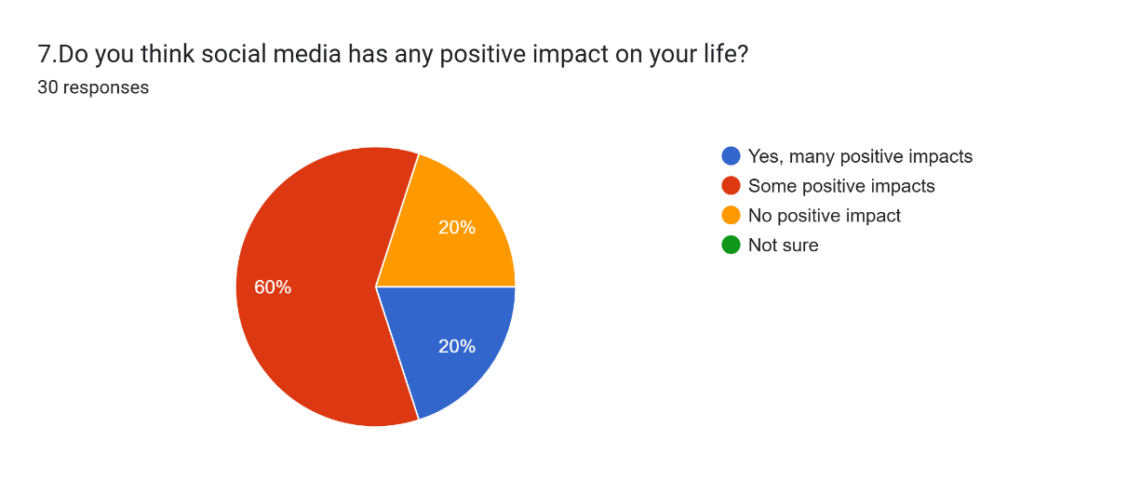
- Not sure: 0%

7. Suggestions for Reducing Addiction
Common ideas from respondents:
- Set daily time limits on apps.
- Practice digital detox days.
- Engage in offline hobbies or social activities.
- Avoid using phones before sleep.
- Turn off unnecessary notifications.

8. Conclusion
The survey findings indicate that while social media helps in communication and entertainment, excessive use can lead to anxiety, sleep issues, and decreased productivity. Most respondents agree that awareness and self-control are crucial to maintaining a healthy digital balance.

9. References
- Data collected via Google Form titled “The Mental Health Effects of Social Media Addiction”.
- Articles and research from WHO, APA (American Psychological Association), and NIMH.
- Respondent feedback and self-reported experiences.

